5.51: a) If the pilot feels weightless, he is in free fall, and 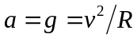, so 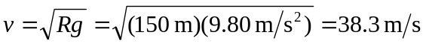, or 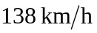. b) The apparent weight is the sum of the net inward (upward) force and the pilot’s weight, or
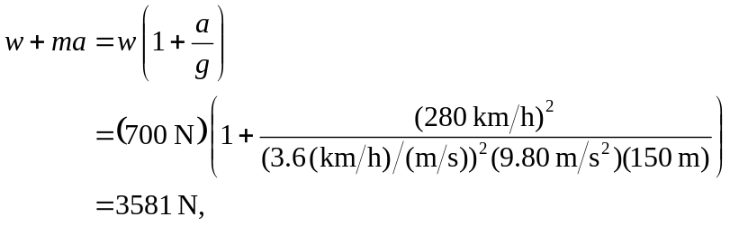
or 3580 N to three places.

